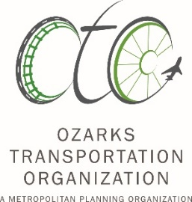
Ozarks Transportation Organization
Bicycle-Pedestrian Advisory Committee
Agenda

June 14, 2022
1:00 pm
OTO Offices
2208 W Chesterfield Blvd., Suite 101
Springfield, MO 65807

- Welcome
- Meeting Notes from 03/08/22 BPAC Meeting: The committee will review and consider approval of the meeting notes from the 03/08/22 BPAC meeting.
Guest Presentation
- US Bike Routes: The committee will hear from David Hutchinson on the proposed routes for USBR 51 and USBR 251 in the OTO area.
Informational Items
- OG Tech Committee Update: Staff will provide an overview of recent Ozark Greenways Tech Committee meetings.
Action Items
- CY 2021 Implementation Report: The committee finalize the CY 2021 Bicycle and Pedestrian Implementation Report.
Discussion Items
- TAP Funding: The committee will brainstorm a list of possible projects for upcoming Transportation Alternative Program funding.
- Pedestrian Safety Analysis: The committee with review and discuss the initial results of a pedestrian safety analysis. Committee members will have an opportunity to suggest changes or revisions.
Other Items
- Project Updates: Committee members will be asked to provide updates on ongoing bike/ped projects within their communities.
- Other: The committee will have the opportunity to discuss other bicycle or pedestrian topics.
- Adjourn

Si usted necesita la ayuda de un traductor del idioma español, por favor comuníquese con la Andy Thomason al teléfono (417) 865-3042, cuando menos 24 horas antes de la junta.
Persons who require special accommodations under the Americans with Disabilities Act or persons who require interpreter services (free of charge) should contact Andy Thomason at (417) 865-3042 at least 24 hours ahead of the meeting.
If you need relay services, please call the following numbers: 711 – Nationwide relay service; 1-800-735-2966 – Missouri TTY service; 1-800-735-0135 – Missouri voice carry-over service.
The OTO fully complies with Title VI of the Civil Rights Act of 1964 and related statutes and regulations in all programs and activities. For more information or to obtain a Title VI Complaint Form, see www.ozarkstransportation.org or call (417) 865-3042.

