# Benefit-Cost Analysis Supplementary Documentation

The purpose of this document is to describe methodologies, provide assumptions, and cite data sources used to prepare the Benefit-Cost Analysis (BCA) for the Highway MM: *Corridor of Opportunity* MPDG application.

The BCA for this grant application is based on a benefit/cost analysis prepared for a RAISE application for phased corridor improvements which includes three phased roadway segment locations. The benefits and cost calculations for the MPDG Rural grant application BCA ratio only include two project locations, Hwy MM from I-44 to MO 360 and Hwy MO 360 to Haile St, component 1 and component 2, respectively. The emissions savings were calculated with output from the OTO Travel Demand Model for all roadways in a local area analysis network and dependent on the build scenario for all original project components.

Table 1 Summary of Benefits



Input values for the BCA can be found on the BCA Parameter Values Tab in the BCA Calculation Workbook as well as the workspaces on each tab.

## Project Description No Build and BUild Scenerio In BCA

The project boundaries are Highway MM from Interstate 44 to Haile Street.

**Build Scenario Characteristics:**

* Widening road to a 4-lane primary arterial with raised medians
* Direct Current Charging Station near Interstate 44
* 5-foot ADA sidewalks along the corridor
* Widening of bridge over MO 360 to accommodate 4-lanes and pedestrian facilities
* Addition of pedestrian crossing and signal at Haile Street

**No Build Scenario Characteristics:**

* 2-lane 3.95-mile north/south minor arterial with two 12-foot wide lanes

**Phase I**

* 3 BNSF railroad crossings
* Three-leg stop-controlled intersection at Farm Road 160 and Highway MM
* No shared use pedestrian and bicycle path

**Phase II**

* No Direct Current Charging Stations in vicinity
* Narrow shoulders and no pedestrian facilities
* 2-lane bridge over MO 360 with no pedestrian accommodations

## Travel Demand Forecasting

The OTO MPO Travel Demand Model was used to forecast a “No-Build” and a “Project Build” scenario for the 2045 model year. The model base year is 2018 and was updated using VISUM version 13.0+ in 2020. The OTO’s 2045 VISUM model was modified to consider the recent improvements and travel behavior within the study area more accurately. The OTO’s consultant, Olsson, updated the model with known and anticipated future developments impacting the MM corridor project segments and surrounding area. A “No-Build” scenario generated travel time, delay, and volumes for 2045 along corridor segments and nearby roads with existing roadway capacities. This analysis network is highlighted in Figure 1.

The “Project Build” scenario incorporated the proposed Highway MM: Corridor of Opportunity improvements to generate travel time, delay, and volumes for 2047 for the build alternative.

Based on the model runs, 2045 daily traffic volumes for “No-Build” and “Project-Build” scenarios were developed for three project segments along the Highway MM corridor.

Model output for only the project corridor segment volumes, mapped in red, were used for the travel time savings analysis.

Model output for all roadways in the analysis network was used to calculate emissions benefits using vehicle hours of delay along the entire analysis network.

Model links for both scenarios were delivered to the OTO in shapefile format. Length weighted ADT for the 2045 model scenario volumes was calculated to correspond with the MoDOT State of the System Segment lengths and 2022 base-year AADT for the three project segments. Tabs in the BCA spreadsheet contain model output from both scenarios.

Figure 1 Project Build and No-Build Scenario Maps

Two additional years were extrapolated from the 2045 model output to agree with the BCA analysis period of 20 years through 204. Although this was discouraged in the BCA guidance, two additional years should have minimal impact.

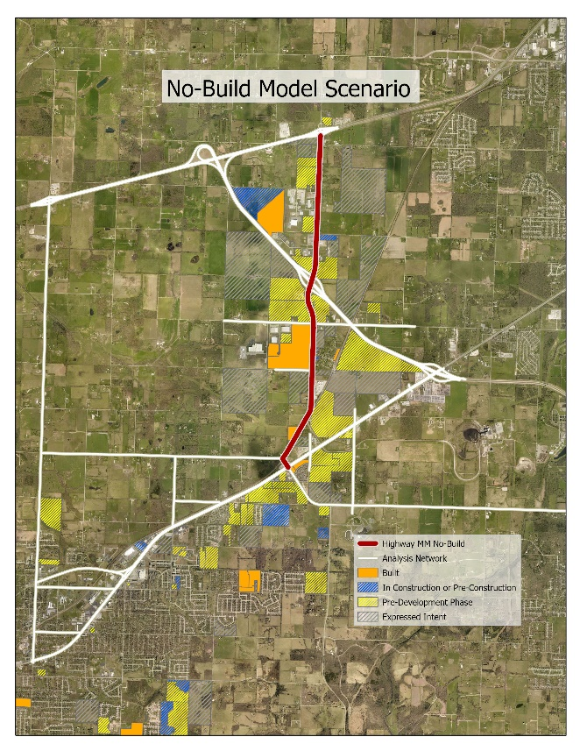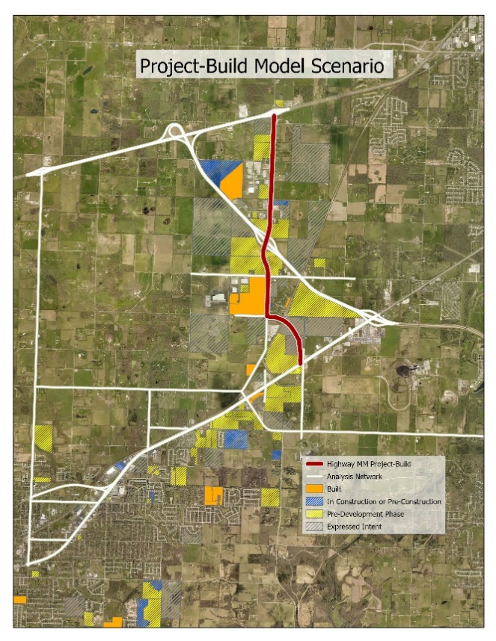

### Travel Demand Model Scenario Traffic Volumes

Table 2 Travel Demand Model Scenario Traffic Volumes

|  |  |  |  |
| --- | --- | --- | --- |
| **Corridor Segment** | **2022 AADT** | **No-Build 2047 AADT** | **Project-Build 2047 AADT** |
| Hwy MM – I-44 to MO360 | 12,957 | 23,857 | 28,718 |
| Hwy MM – MO360 to Haile St | 7,693 | 18,630 | 26,333 |

*Both sections share one segment in MoDOT GIS Data

### Travel Time Savings

Assumptions:

* Highway MM from Haile St. to State Highway 360 is expected to reach Level-of-Service F using passenger car equivalent volumes by 2027.
* Free flow speed is estimated to be 95% of the posted speed limit.
* Daily roadway capacity used for each scenario is developed from research completed by the Florida DOT based on the 2010 Highway Capacity Manual. A value of 8,450 vehicles per lane per day (vplpd) is used as the baseline for the No-Build two-lane rural arterial and 7,900 vplpd for the Project-Build suburban four-lane arterial placing the capacity values at 16,900 and 31,600, respectively.
* Growth in annual daily traffic was applied incrementally throughout the analysis period for each project segment: (2047 ADT - 2022 ADT)/(2047 – 2022)
* Percentage speed from the LOS table was used to calculate travel time in minutes for peak and off-peak periods: Length (Miles)/(Speed (mph)/60)
* Travel time differences between No Build and Project Build were used to calculate benefits incrementally across the analysis period.

The following tables depict the percentage of free flow speed (PFFS) based on the Level of Service (LOS) for two-lane highways and a derived LOS for arterials based on volume-to-capacity ratios. Vehicle occupancy rates were not applied to the TTS due to lack of detailed factors for weekday peaks and composition of travel.

Table 3 Level of Service Criteria for Two-Lane Highways

|  |  |  |  |  |
| --- | --- | --- | --- | --- |
|  | **Class I Highways** | | **Class II Highways** | **Class III Highways** |
| LOS | ATS (mi/h) | PTSF (%) | PTSF (%) | PFFS (%) |
| A | > 55 | <=35 | <= 40 | >91.7 |
| B | >50 - 55 | >35 - 50 | >40 - 55 | >83.3 – 91.7 |
| C | >45 - 50 | >50 - 65 | >55 – 70 | >75 – 83.3 |
| D | >40 - 45 | >65 - 80 | >70 – 85 | >66.7 – 75 |
| E | >= 40 | >80 | >85 | <=66.7 |
| F | Demand Exceeds Capacity | | | |
| Source: <https://www.smatstraffic.com/2021/07/26/level-of-service/> Highway Capacity Manual: Sixth Edition | | | | |

Table 4 Level of Service Criteria for Arterials Based on Volume-to-Capacity Ratios

|  |  |  |
| --- | --- | --- |
| **LOS** | **Description** | **V/C Ratio** |
| A | Free flow conditions with unimpeded maneuverability. Stopped delay at signalized intersection is minimal. | 0.0 to 0.6 |
| B | Reasonably unimpeded operations with slightly restricted maneuverability. Stopped delays are not bothersome. | 0.61 to 0.7 |
| C | Stable operations with somewhat more restrictions in making mid-block lane changes than LOS B. Motorists will experience appreciable tension while driving. | 0.71 to 0.8 |
| D | Approaching unstable operations where small increases in volume produce substantial increases in delay and decreases in speed. | 0.81 to 0.9 |
| E | Operations with significant intersection approach delays and low average speeds. | 0.91 to 1.0 |
| F | Operations with extremely low speeds caused by intersection congestion, high delay, and adverse signal progression. | > 1.0 |
| Source: <https://ccag.ca.gov/wp-content/uploads/2014/07/cmp_2005_Appendix_B.pdf> Transportation Research Board, Highway Capacity Manual, Special Report 209 (Washington, D.C., 1994) | | |

For No-Build and Project-Build scenarios, the base free flow speed along the corridor is conservatively estimated to be 95% of the posted speed limit. Regardless of whether the project is implemented, the City of Republic and MoDOT staff have indicated the posted speed limit will be reduced to 45 mph from 55 mph. Using these parameters, it is possible to compare travel speeds for the No-Build and Project-Build scenarios and calculate annual travel time savings due to the implementation of the project. Most parameters used to calculate travel time savings benefits are available on [MoDOT’s Datazone AADT Map](https://datazoneapps.modot.mo.gov/bi/apps/publicmaps/Home/MapConfig/AADT) web application.

Table 5 Parameters Utilized to Calculate Travel Time Benefits



Sources: [MoDOT Datazone AADT Map](https://datazoneapps.modot.mo.gov/bi/apps/publicmaps/Home/MapConfig/AADT), OTO Travel Demand Model

There are positive **Travel Time Savings** of **$9,484,569** over the 20-year period.

## Safety Analysis

Assumptions:

* There will be a decrease in crashes of all severity types after the two-lane rural highway is converted to a divided four-lane suburban arterial with raised medians.

Data used to calculate safety benefits were provided by MoDOT. Seven years of crash data from 1/1/2017 to 12/31/2023 were exported from MoDOT’s [datazone](https://modatazone.modot.org/) crash statistics map and used to calculate a baseline of annual averages for fatality, disabling & suspected serious injury, minor injury, and property damage only crashes. The following table summarizes the seven years of crash history at specific locations of planned improvements on the Hwy MM corridor.

In the Project-Build scenario there is a positive discounted **Safety Benefit** **of $41,750,428** savings over the 20-year period.

### Crash History

Table 6 Crash History by Location

|  |  |  |  |  |  |
| --- | --- | --- | --- | --- | --- |
| **Location** | **Fatality** | **Disabling/Suspected Serious Injury** | **Minor Injury** | **PDO** | **Total** |
| Hwy MM – I-44 to MO360 | 0 | 4 | 11 | 41 | 56 |
| Hwy MM – MO360 to Haile St. | 1 | 4 | 10 | 31 | 46 |
| Source: <https://modatazone.modot.org/index.php/safety> | | | | | |

### Crash modification factors

OTO staff used Highway Safety Manual (HSM) safety performance function spreadsheets to calculate expected crash frequencies for rural two-lane highways and multi-lane suburban arterials to reflect the No-Build and Project-Build scenarios using baseline crash statistics for each roadway segment and each intersection comprising the project locations.

The HSM Part C provides a predictive method for estimating expected average crash frequencies at individual sites. This method relies on safety performance functions (SPF) that estimate predicted average crash frequency as a function of traffic volume and roadway characteristics (e.g., number of lanes, median type, intersection control, number of approach legs).’ <https://highways.dot.gov/safety/data-analysis-tools/highway-safety-manual>

A multi-year analysis was run for each scenario using 2023 as a base year covering 25 years through 2047 with a conservative linear traffic growth rate of 1.8%. This resulted in crash frequencies using the KABCO scale for each year in the analysis period. Comparisons of the expected crash frequencies for each year in the no-build and project-build roadway conditions were used to calculate CMFs for each year in the analysis period. MoDOT crash severity levels were converted to the KABCO equivalent to calculate safety benefits consistent with the HSM reports. MoDOT’s equivalent KABCO level is presented below.

Table 7 MoDOT Crash Severity Level Conversion to KABCO

|  |  |
| --- | --- |
| MoDOT (MAIS) Level | KABCO Level |
| Fatal | (K) - Killed |
| Disabling/Suspected Serious Injury | (A) - Incapacitating |
| Minor Injury | (B) - Non-incapacitating |
| - | (C) - Possible Injury |
| PDO | (O) - No Injury |
| - | (U) - Injured (Severity Unknown) |

The calculation of a CMF with treatment is as follows:

|  |  |
| --- | --- |
| CMF = | Expected crash frequency with treatment |
| Expected crash frequency without treatment |

Applying the values for expected crash frequencies for each scenario to the CMF formula for each year in the multi-year analysis resulted in annual CMF the Project-Build scenario.

Table 9 CMFs Derived from the Multi-Year Analysis for Two-Lane Conversion to Urbanized Arterial

|  |  |  |
| --- | --- | --- |
| **Year** | **KABC CMF** | **PDO CMF** |
| 2023 | 0.871 | 0.95 |
| 2024 | 0.872 | 0.96 |
| 2025 | 0.873 | 0.96 |
| 2026 | 0.874 | 0.96 |
| 2027 | 0.875 | 0.96 |
| 2028 | 0.876 | 0.96 |
| 2029 | 0.877 | 0.96 |
| 2030 | 0.878 | 0.97 |
| 2031 | 0.878 | 0.97 |
| 2032 | 0.879 | 0.97 |
| 2033 | 0.880 | 0.97 |
| 2034 | 0.880 | 0.97 |
| 2035 | 0.881 | 0.97 |
| 2036 | 0.882 | 0.98 |
| 2037 | 0.882 | 0.98 |
| 2038 | 0.883 | 0.98 |
| 2039 | 0.883 | 0.98 |
| 2040 | 0.883 | 0.98 |
| 2041 | 0.884 | 0.98 |
| 2042 | 0.884 | 0.98 |
| 2043 | 0.885 | 0.98 |
| 2044 | 0.885 | 0.99 |
| 2045 | 0.885 | 0.99 |
| 2046 | 0.886 | 0.99 |
| 2047 | 0.886 | 0.99 |

The annual safety benefit for each segment was calculated by applying the CMFs for that year to the annual averages for that location’s crash severity levels and subsequently monetizing the crash severity level reduction to sum benefits for all locations for each year.

** Emissions Analysis

Assumptions:

* Zero emission electric vehicles will grow to 2% of all passenger vehicles by 2027 and increase by 1% per year throughout the analysis period reaching 20% by 2047.
* The annual difference in vehicle hours of delay between the No-Build and Project Build model scenarios were calculated incrementally for each year in the analysis period and used to determine grams of pollutants and fuel consumption.

The emissions benefit calculation is based on the OTO 2045 Travel Demand Model runs for the No-Build and Project-Build scenarios for the complete analysis network that includes roadways that are expected to be heavily influenced by the project. Annual vehicle hours of delay for each year in both model scenarios throughout the analysis period were calculated on the “No Build 2045 Model Output” and “Project Build 2045 Model Output” tabs in the BCA workbook, respectively. The yearly difference in vehicle hours of delay between the No-Build and Project Build scenarios was used to calculate the savings in emissions from the No-Build and Project-Build Scenarios. Idle emission rates in grams per hour were applied to the difference in vehicle hours of delay for the percentage of trucks vs passenger vehicles on the analysis network. Emission rates were derived from the EPA. The following tables provide the values for emission rates and short ton to metric ton conversion.

Table 10 Average Idle Emissions Rates (grams per hour)

|  |  |
| --- | --- |
| **Light Duty Gasoline Vehicles** | |
| Volatile Organic Compounds (VOC) | 2.683 |
| Nitrogen Oxide (NOx) | 3.515 |
| Particulate Matter (PM2.5) | N/A |
| Sulfer Dioxide | N/A |
| **Heavy Duty Diesel Vehicle** |  |
| Volatile Organic Compounds (VOC) | 3.455 |
| Nitrogen Oxide (NOx) | 33.763 |
| Particulate Matter (PM2.5) | 1.1 |
| Sulfer Dioxide | N/A |
| [Idling Vehicle Emissions for Passenger Cars, Light-Duty Trucks, and Heavy-Duty Trucks, EPA, October 2008](https://nepis.epa.gov/Exe/ZyNET.exe/P100EVXV.txt?ZyActionD=ZyDocument&Client=EPA&Index=2006%20Thru%202010&Docs=&Query=&Time=&EndTime=&SearchMethod=1&TocRestrict=n&Toc=&TocEntry=&QField=&QFieldYear=&QFieldMonth=&QFieldDay=&UseQField=&IntQFieldOp=0&ExtQFieldOp=0&XmlQuery=&File=D%3A%5CZYFILES%5CINDEX%20DATA%5C06THRU10%5CTXT%5C00000033%5CP100EVXV.txt&User=ANONYMOUS&Password=anonymous&SortMethod=h%7C-&MaximumDocuments=1&FuzzyDegree=0&ImageQuality=r75g8/r75g8/x150y150g16/i425&Display=hpfr&DefSeekPage=x&SearchBack=ZyActionL&Back=ZyActionS&BackDesc=Results%20page&MaximumPages=1&ZyEntry=1) | |

Table 11 Unit Conversions

|  |  |
| --- | --- |
| Grams per US Short Ton | 907,185 |
| Metric Ton to Short Ton | 1.1 |

The damage costs for NOx and PM2.5 emissions were calculated based on the yearly value per metric ton in Table A-6 in the December 2023 US DOT BCA Guidance for Discretionary Grant Programs.

Idling Fuel Use Supporting Information

Table 12 Idling Fuel Use Supporting Data Parameters

|  |  |  |  |  |
| --- | --- | --- | --- | --- |
| **Vehicle Type** | **Fuel Type** | **Engine Size (Liter)** | **Gross Vehicle Weight** | **Idling Fuel Use (Gal/Hr with No Load)** |
| Compact Sedan | Gas | 2 | - | 0.16 |
| Large Sedan | Gas | 4.6 | - | 0.39 |
| Compact Sedan | Diesel | 2 | - | 0.17 |
| Medium Heavy Truck | Gas | 5-7 | 19,700-26,000 | 0.84 |
| Delivery Truck | Diesel | - | 19,500 | 0.84 |
| Tow Truck | Diesel | - | 26,000 | 0.59 |
| Medium Heavy Truck | Diesel | 6-10 | 23,000-33,000 | 0.44 |
| Transit Bus | Diesel | - | 30,000 | 0.97 |
| Combination Truck | Diesel | - | 32,000 | 0.49 |
| Bucket Truck | Diesel | - | 37,000 | 0.9 |
| Tractor Semi-Trailer | Diesel | - | 80,000 | 0.64 |
| <https://www.energy.gov/eere/vehicles/fact-861-february-23-2015-idle-fuel-consumption-selected-gasoline-and-diesel-vehicles> | | | | |

Idling Fuel Use for passenger cars used the average gas use for Compact and Large Sedans (0.275) and the value for Combination Trucks (0.49) applied to the 2022 commercial percentage on the analysis network. The damage costs for CO2, NOx, and PM2.5 emissions were calculated based on the yearly value per metric ton in the December 2023 US DOT BCA Guidance for Discretionary Grant Programs.

Pedestrian Trail Addition VMT Reduction Emissions Calculation

Consideration was taken for the CO2 reduction that the new pedestrian walking trail would contribute. Utilizing a formula published by the California Air Resources Board in a publication found here: <https://ww2.arb.ca.gov/sites/default/files/auction-proceeds/pedestrian_facilities_technical_041519.pdf> the VMT reduction was calculated below:

Table 13 Auto VMT Reduced Formula



* + Estimated passenger car (light duty) at 22.2 mpg and Trucks and Busses at 12 mpg.
  + Conservatively estimated daily traffic at 90% light duty and 10% heavy duty trucks and busses.
  + Using the mpg values, converted vehicle miles travelled to gallons of fuel by vehicle type based on VMT reduced.
  + Multiplied grams of CO2 released per gallon of gasoline (8,897) and diesel (10,180) for light duty and heavy duty traffic, respectively.
  + Grams were converted to US short tons by dividing by 907,185 (the number of grams per short ton).
  + Multiplied short tons by the cost of CO2 by calendar year.
  + Guidance from (<https://www.epa.gov/greenvehicles/greenhouse-gas-emissions-typical-passenger-vehicle#burning>)

This project reduces CO2 emissions by **5.14 US Short Tons** per year from the addition of the new pedestian facilities from Haile Street to US 50. This would be **102.82 US Short Ton**s over the 20 years. There is **CO2 Emission Reduction Benefits** of **$7,070,468** and **Non-CO2 Emission Reduction Benefits** of **$1,903,619**.

** Operating & Maintenance Costs

Operating and Maintenance Costs for the Highway MM corridor were provided by MoDOT. Baseline per lane-mile costs for patching, mowing, signing, snow removal, signals, and a 10-year resurfacing cycle were calculated and applied to the existing No-Build lane-miles (7.6) to create a base year value. A three percent rate of inflation was applied year-over-year throughout the analysis period. The per lane-mile costs were then applied to the Project-Build lane-miles (14.09) and inflated at three percent year-over-year through the analysis period. The No-Build costs were subtracted from the Project-Build costs resulting in $1,220,028 Discounted Total.

Table 14 Cost of Maintenance Mile

,

** Amenity Benefits

The BCA Guidance provides recommendations for pedestrian facilities. Benefits were quantified for the following project improvements, based on a conservative AADT along the sidewalk and trail additions and a 1% annual increase sidewalk and 2% increase on the shared use path:

* Average walker trip mile .86 mile
* Expanded or new sidewalk width – 5-ft
* Expanded or new trail width – 10-ft
* Reduction of Traffic Speed by 1 mph – 10 mph reduction for sidewalk calculations
* Days per year sidewalk and trail in use – 340 days (to account for severe weather occurrence)
* Total Pedestrian Facility Improvement Value Sidewalk - $1.45
* Total Pedestrian Facility Improvement Value Shared Use Path - $1.10

The corridor currently does not have sidewalks available for pedestrians. A conservative estimate of 100 AADT from Haile Street to MO 360, and 30 AADT from MO 360 to I-44 was assumed. The positive discounted **Amenity Benefit** of **$290,180** is realized along the corridor.

Table 15 Pedestrian Facility Inputs



** Health Benefits of Induced Active Transporation Values

The BCA Guidance provides recommendations for Mortality Reduction Benefits of Induced Active Transportation Values.

Table 16 Mortality Reduction Benefit Input – Pedestrian



Values from December 2023 BCA Guidance. Pedestrians from estimate of daily walkers. Springfield, MO trail counts average weekly walkers from March to September 2020 1,560. Total average usage of trail segment in Springfield area from March to September 56,160. Numbers used here are conservative and below the local average.

Table 17 Mortality Reduction Benefit Input – Bicyclist



The Ozark Greenways (ozarkgreenways.org) is a regional nonprofit that maintains and advocates for trails in the Springfield, MO region. The organization has trail counts on Springfield region trails. Using these trail count baselines, the BCA utilized bicycle and pedestrian counts that were below the local average to ensure conservative factors were applied. The BCA worksheet has a tab with the trail counts for comparison (Springfield Region Trail Counts). In addition, the national average factor of .59 for bicyclists and 0.68 for pedestrians were applied since the local trail counts did not differentiate between visitor age. The **Health Benefits** for Pedestrians and Bicyclists is **$4,000,982.**