**HIghway mm: *corridor of opportunity***

# Outcome Criteria

The Highway MM: *Corridor of Opportunity* project creates phased improvements to Highway MM between I-44 and US Highway 60. MPDG – Rural grant funds will contribute to improvements which run from I-44 to Haile Street near an Amazon fulfilment center. The *Corridor of Opportunity* access improvements are essential to support the growing economy of the rural area. The project connects the Springfield-Branson National Airport, with a foreign trade zone, to an Enhanced Enterprise Zone, several industrial employers, mixed-use districts, a new intermediate school, and a planned Republic Parks Sports Complex. Improvements to Highway MM will reduce safety risks for motorized and non-motorized travelers, ensure a state of good repair, meet capacity demands from economic growth, address airborne particulates, improve regional quality of live, provide connectivity between the City of Republic and surrounding rural areas, and use innovative project delivery methods.

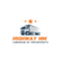

## Criterion #1: Safety

Project improvements will reduce fatalities/serious injuries, improve emergency response times, protect motorized and non-motorized travelers, and achieve goals set out in the 2022 National Roadway Safety Strategy.

**Reduce Fatalities and/or Serious Injuries**

In 2023, the Republic Police Department responded to 54 vehicle crashes at US 60 and Hwy MM as well as 17 crashes at MO 360 and Hwy MM. These two crash locations were ranked first and fourth on Republic PD’s “Top Five Crash Locations – 2023”. The funded Phase I realignment of Hwy MM will create a safer alternative intersection for Hwy MM with US 60 minimizing opportunities for collision. This project application addresses the Phase II Hwy MM and MO 360 crash location. The project turns a two-lane arterial into a divided four-lane with raised median facility. Improvements will enable the corridor to more safely absorb the increased traffic flow caused by population growth, industrial growth, and the realignment of Hwy MM scheduled for completion 2025. Hwy MM from Haile Street to I-44 will attract freight traffic that will utilize the new Hwy MM intersection at US 60 to travel to I-44. Presently, there are 87 bus trips daily during the school year along Hwy MM, serving Republic High School's 1,500 students. The construction of an 800-student intermediate school along the new Hwy MM alignment will increase student traffic along Hwy MM.

The lack of sidewalks on Hwy MM also creates an unsafe environment for pedestrians. On September 27th, 2020, a pedestrian died due to a traffic accident at Hwy MM and MO 360. The addition of ADA sidewalks will help prevent tragedies like the one in 2020.

***Railroad Safety***

Phase I of the Hwy MM Corridor project will construct a railroad overpass to allow vehicles to

traverse Burlington Northern Santa Fe (BNSF) Cherokee Subdivision railroad track. Three at-grade railroad crossings will be closed with the Phase I project.

*Emergency Response*

The project will provide a dependable 24-hour route for emergency response vehicles serving the City of Republic. The Brookline Fire District, Republic Fire Station Number Two, and the Cox Ambulance District, are north of US 60 with Hwy MM being the primary route. Hwy MM Improvements will reduce response times and assist public safety staff responding to incidents on Interstate 44, MO 360, and US 60.

**Significantly Protects Vulnerable or Non-motorized Travelers from Health and Safety Risks**

A ***primary project***purpose is to remove pedestrians from the roadway and create a connected sidewalk/trail network to allow pedestrians to walk along the corridor. The current “No Build” corridor has no sidewalks, creating an inhospitable walking environment. Most of the road is a rural two-lane open shoulder design. Partners on this project seek to prevent another incident like the 2020 pedestrian death near the MO 360 on-ramp.

In response to public feedback, the project emphasizes the need for a continuous sidewalk from US 60 to MO 360. Adding 5-foot ADA sidewalks to the corridor will provide pedestrian safety.

**Figure 1 Magellan Midstream Partners on Hwy MM**

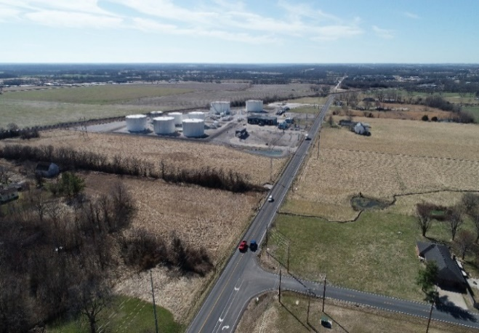

**Significantly Reduces Fatalities and/or Serious Injuries of Motorized Travelers**

The “No Build" original segment of Hwy MM is a two-lane undivided roadway curving southwest. The posted speed limit is currently 55 mph. Magellan Midstream Partners L.P. fuel tanks are located along the corridor. Tankers pull in and out of the regional fuel pipeline facility daily.

The semi-truck traffic generated from the businesses have placed an increased safety risk on the road. Amazon Fulfillment Center, Convoy of Hope Worldwide Headquarters, and McLane Ozark have all built along the corridor in the past ten years. Garton Business Park is actively marketed to developers. Tax abatement incentives will drive further development and increase semi-truck traffic in the already fast developing area.

Amazon invested in roadway safety by widening the area in front of the facility to three-lanes and adding a signalized intersection in front of its facility. This project will ***provide for roadway safety*** by widening from two-lanes to a divided four-lane arterial with raised medians. Improvements will allow the “No Build” vehicle AADT of 23,857 in 2045 to safely maneuver

the corridor. The AADT (which excludes current economic development) is 12,957 AADT. Between 2017 and 2023 there were 102 total crashes on this segment of Hwy MM.

There are sharp curves, narrow two-foot shoulders and rumble stripes throughout much of the corridor. This contributes to deficient space for errant vehicle recovery. A minimum of 22-feet of clear zone will be included in the project.

**Implements Actions Identified in the National Roadway Safety Strategy Plan**

This project incorporates several key safety countermeasures for safer roads from the National Roadway Safety Strategy Plan. The project will lower the posted speed from 55 mph to 45 mph to promote safer passage and reducing serious injury crashes and fatalities. The project incorporates proven safety countermeasures such as raised medians, a wider clear zone, and use of pedestrian walkways such as sidewalk, pedestrian crosswalk, and pedestrian accommodations on the MO 360 bridge.

Figure 2 Crash Heat Map 2015-2019

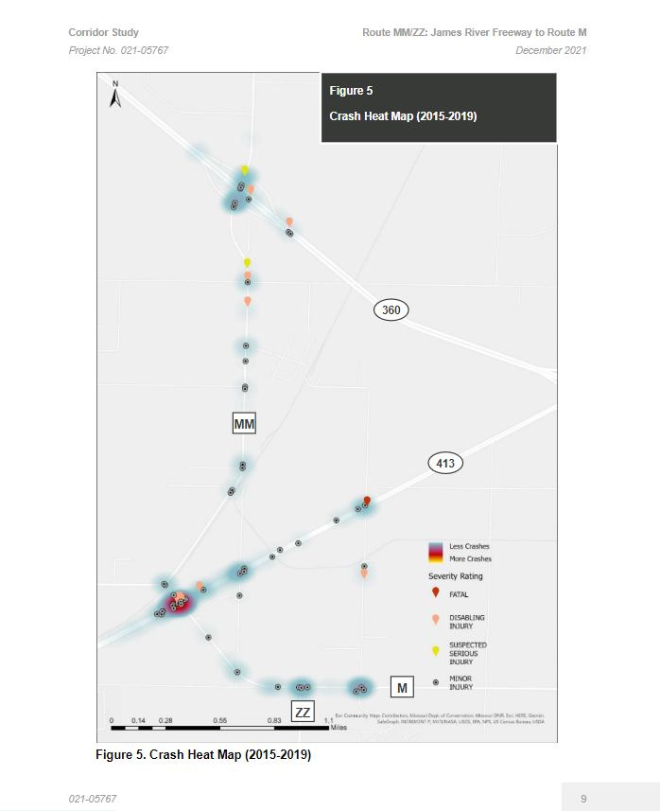

***Lighting***

LED lighting will be installed at intersections and medians to help pedestrians safely traverse the corridor and cross at intersections. Lighting is a proven safety countermeasure and research indicates that continuous lighting on rural and urban highways has an established safety benefit for motorized vehicles.

***Pedestrian Crosswalk***

There is a planned pedestrian crosswalk and signal at Haile Street near the Amazon fulfilment facility and the Iron Grain Mixed-Use complex. This provides a safe connection across Hwy MM for the Amazon workers and individuals living in adjacent mixed-use housing to cross the road to jobs.

Overall there is a positive **Safety Benefit Return** on Investment of **$41,750,428** illustrating the high safety benefits of improvements to the corridor.

## Criterion #2: State of good repair

The Hwy MM corridor improvements will significantly upgrade the highway and rail transit system that runs through the City of Republic. Corridor expansion will improve existing asphalt, which is maintained on a seven-year cycle.

**Restores and Modernizes Existing Core Infrastructure**

MPDG grant investment will create a new infrastructure system that will connect a remote community to an urban zone. The project includes primary design improvements by turning the two-lane rural route into a four-lane primary arterial with a raised median. The widening of MO 30 allows for multi-modal pedestrian access that currently does not exist. The bridge improvements over MO 360 are expected to have a service life of 50 years. The rest of the corridor will have a BCA service life of 20 years. In addition to the long service life of the bridge improvements, the “Project Build” scenario will have capacity through 2048. The “No Build” scenario will be over capacity by 2027. This new infrastructure will replace the maintenance coming due on the existing asphalt.

**Reduce Construction and Maintenance Burdens through Efficient, Well-Integrated Design**

* The completed corridor with Phase I & II will be shorter at 3.61-mile “Project-Build” scenario’s O & M cost of $14,824.33 per mile versus the 3.84 mile “No-Build” scenario has an O & M cost of $15,146.55 per mile.
* The new segment will offer long-term maintenance cost savings with the installation of LED bulbs in the street lighting along the corridor.

**Addresses Current Vulnerabilities that if Left Unaddressed will Threaten Future Transportation Network Efficiency, Mobility of Goods or People, and Economic Growth**

Phase I of the Highway MM Corridor is addressing serious safety concerns, such as closing three at-grade railroad crossings, building an overpass over a busy BNSF rail line, and creating a new road realignment to address intersection traffic stacking onto a railway. These improvements are scheduled to begin construction in 2025. In addition, there is a new intermediate school and mixed housing located along the Phase I project. Once this improved segment opens the increased traffic consisting of school buses, semi-trucks, and passenger cars will come to a bottle neck at Haile Street where it returns to a rural two-lane segment.

Figure 3 Hwy MM Bridge over MO 360

In addition, the current “No Build” has two lanes, and bottlenecks before MO 360. Without the project intervention, in the “No Build” scenario, the level of service is expected to be E/F using passenger car equivalent AADT by 2027, based on the current capacity for rural two-lane roads (13,000 AADT). By 2045, the expected “No Build” AADT is 23,857. Without the roadway improvements, there will be congestion delays that affect personal drivers and businesses who rely on freight and delivery trucks. Reliability will be enhanced through the corridor’s additional lanes and raised medians.

**Party Responsible for Maintenance**

MoDOT design standards will serve as the basis for design and the corridor will remain on the MoDOT transportation system for normal and routine maintenance.

## criterion #3: Economic impacts, freight Movement and Jobs

**Economic Impact & Growth**

Figure 4 Development Map

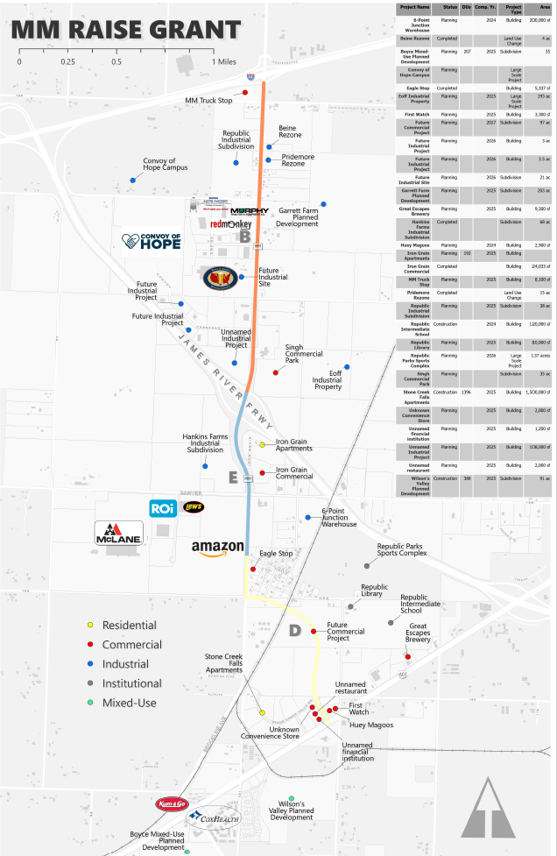

Republic has been growing at a rate of 3.9% due to its proximity to Springfield and availability of land. Republic is planning now for this growth and is taking preemptive measures to create a community through planned and deliberate transportation decisions, including this project. Republic has streamlined licensing and permit processes, paved roads, built new lift stations, and installed infrastructure to increase water and sewer lines capacity to accommodate commercial development.

The coordinated realignment of Hwy MM and widening of the road will allow citizens and the private sector in the region to leverage the comparative advantage of access to I-44 and MO 360. With improvements to the BNSF rail lines, railroad spurs can also be added to improve freight transportation.

Amazon saw the location’s potential and built a 1.3 million-square-foot warehouse and distribution facility. This freight-intensive facility is critical to meeting Missouri’s demand for goods and depends on a safe/efficient roadway per the 2022 MoDOT State Freight and Rail Plan <https://tinyurl.com/MM2024MPDG>.

**Enhanced Enterprise Zone**

To maximize the benefits of the location and incentivize growth, the City of Republic, Missouri’s Department of Economic Development, and the Republic Chamber of Commerce established an Enhanced Enterprise Zone (EEZ) which offers the incentives of local property tax

abatement and state tax credits to new and expanding businesses that qualify. The EEZ boundary includes the area adjacent to Hwy MM between Interstate 44 and US 60.

Growth will continue, quality transportation infrastructure is needed. There are hundreds of acres of developable land that is suitable for industrial and commercial uses with the potential to employ thousands of workers across numerous rural counties in Southwest Missouri, most of which are designated as “economically distressed” along the corridor. Presently under development, adjacent to the corridor are 844 acres (565 industrial, 36 manufacturing, 118 commercial, and 47 retail). With a low-density build-out estimate of 0.19 percent an acre, a footprint of 207 acres built out, and a factor of 1,487 square ft per job, there could be up to 6,077 jobs once full build out of the pending developments are completed. 2,000 jobs is the conservative number currently projected. More concentrated development would increase that figure. Continued expansion of residential developments in the area could reduce urban sprawl and create a unique live-work industrial/rural dynamic that fits with the Ozark spirit. The City of Republic is prepared for growth and is investing $150 million in water and wastewater infrastructure in the next 5 years to help the area develop. Without the “Build Scenario,” development will not be able to reach its full potential due to roadway limitations. The “No Build Scenario” will stifle economic opportunities and limit job growth for individuals moving to the area because housing is still being built and is cheaper than other suburbs of Springfield.

**Freight Improvement**

Highway MM connects two major freight corridors. Interstate 44 has been identified as a critical Tier I high priority freight corridor in the State of Missouri. See *2022 Missouri State Freight and Rail Plan* here: <https://tinyurl.com/MM2024MPDG>.

Highway MM also connects to US 60, a 2,655-mile (in total) east/west route which runs the entire length of Missouri connecting Oklahoma to Kentucky. It is also a major east-west route connecting Southwestern Arizona to the Atlantic Ocean in Virginia. These key corridors transport vital products to the whole nation. Missouri is a national crossroads of highway, rail, and pipeline networks.

Freight haulers can use Hwy MM to go directly from US 60 to Interstate 44, or to the Springfield-Branson National Airport which is 2.98 miles from Hwy MM. Through the efforts of the Airport, and local US Customs office, Southwest Missouri is also a Foreign Trade Zone, a known catalyst for economic growth. **Currently, 630 million tons of freight valued at over $1.7 billion dollars travel down US 60 and 1.3 billion tons of freight valued at $3.7 billion travel through Interstate 44**(2022 MoDOT State Freight and Rail Plan) <https://tinyurl.com/MM2024MPDG>.

Hwy MM’s intersection with I-44 and MO 360 creates a significant opportunity to move freight and goods necessary to the regional supply chain. Improvements could also divert traffic from Highway N/Main Street (the historic and retail district of Republic) creating more walkability in the area.

Corridor upgrades will reduce travel times for those that live in Republic but work in Springfield. Hwy MM upgrades will also enhance Republic’s capacity to serve as an urban hub to small urban and rural communities, including the cities of Willard, Clever, Billings, and Aurora. Republic offers industrial living wage employment as well as essential shopping and services for individuals living in rural towns west of Republic and Springfield. Improving travel time reliability ensures these individuals can continue to rely on Hwy MM to reach the City of Republic for

Figure 5 Rural Service Area

important services such as health care, groceries, and tourism centers such as Wilson Creek National Battlefield.

**Job Creation**

Greene County currently has a high percentage of low wage earners. Greene County’s average wage was $25.40 in 2022 below the Missouri average of $28.92 <https://meric.mo.gov/data/county-average-wages>. Jobs created in this corridor have higher than the average wages and provide good benefits. These low-barrier jobs are ideal for promoting socioeconomic mobility. Republic is home to historically disadvantaged Census Track 48.02. Residents in impoverished Census Tracts 32, 33, 31 and 17 in Springfield are also within driving distance. Per the OTO Equity Index, residents within a half mile of the MM Corridor Project experience poverty at a higher rate (nearly 20%) compared to the encompassing Census tract (6.7%).

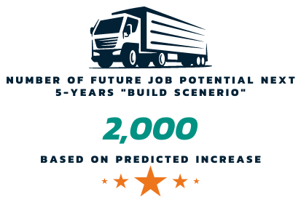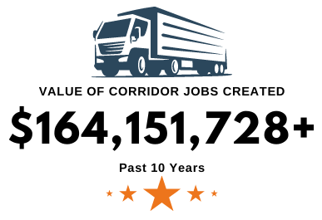

Housing is filling in between this area and Springfield, giving people an opportunity to improve their financial situations by locating close to quality jobs. Multi-family apartments have been constructed close to these job centers and more housing units are planned. This area is only 2.96 miles to already existing grocery and retail centers. In addition to being close to work and commercial necessities, these employees will also be near a new City Park Complex and walking trail.

Table 1 Hwy MM Employment by the Numbers Past 10 Years





## criterion #4: Climate Change, reslience & the Environmental

Environmental Sustainability is a ***primary project* *purpose*** and is achieved by reducing emissions reductions, improving traffic efficiency through congestion reduction and alternative transportation, incorporating electrification, improving resilience, efficient land use, and supporting water quality.

The project’s positive Environmental Return on Investment is **$7,070,468 in CO2 Emission Reduction and $1,903,619 in Non-CO2 Emission Reductions.**

Reduce Transportation-Related Air Pollution and Greenhouse Gas Emissions

Due to existing and known planned developments, traffic is expected to increase significantly along the corridor. Without improvements to the existing network, congestion along the roadway and at the existing at-grade railway crossings will mean increased idling and contributions to ozone-forming and greenhouse gas emissions. From nearing non-attainment for ozone in 2007 with a design value of 77 ppb, the current 2020-2022 quality assured design value is 61 ppb. The Ozarks Transportation Organization maintains a Congestion Management Process and an Operations Subcommittee to collaborate with members such as the City of Republic and partners like MoDOT, in order to identify causes of congestion and to recommend projects that reduce idling and other emissions-inducing traffic concerns. Additionally, the region has consistently remained

below the standards for PM2.5 for both 24-hour and annual measures and is expected to remain in attainment with the newly strengthened PM standard.

Project traffic improvements will support the reduction of idling along the corridor. The new alignment of Hwy MM is shorter than the “No Build” Hwy MM, resulting in fewer vehicular miles. The project improves level of service (LOS) and travel times, from an LOS F to an E/D for the segment from I-44 to MO 360. Daily minutes of delay is nearly half with the project-build scenario (11.75 vs. 22.88 in minutes). Given projected traffic through this corridor, these improvements will contribute to the reduction of ozone-causing emissions, as well as PM2.5 and greenhouse gas emissions from CO2. This project mitigates the increased emissions that would arise from a “No-Build” scenario. These emissions savings are only realized with the completion of both Phase I and Phase II to prevent traffic bottlenecks and congestion.

Figure 6 EV Chargers

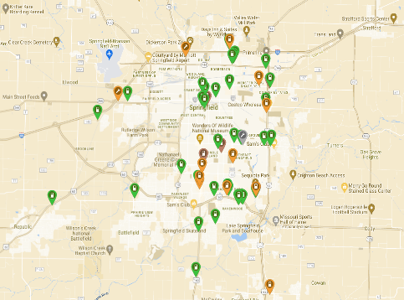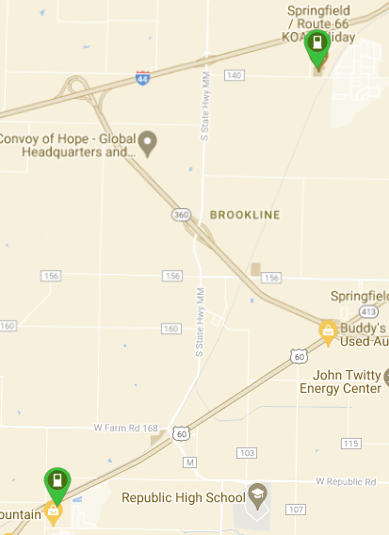

Electrification

The incorporation of a DC-fast charging electric vehicle charger will be a benefit to those that live near the Hwy MM corridor and those traveling along I-44, a pending EV Alternative Fuel Corridor. Currently, the Alternative Fuels Data Center shows 83 miles between compliant chargers. This would reduce that distance to 30 miles in one direction. There are very few electric vehicle chargers meeting any standard on this side of Greene County, as seen on plugshare.com.

Resiliency

Resilience is crucial given Missouri's varied weather and potential for natural and man-made disasters. Hwy MM, linking major highways I-44, MO 360, and US 60, is vital for detours or evacuations. The no-build scenario is projected to have 986,538 annual hours of delay in 2027 and as much as 1,572,295 annual hours of delay in 2048. The no-build scenario level of congestion greatly diminishes the effectiveness of Hwy MM for detours, compared to the opportunity this improvement provides. Increasing the capacity of this roadway from 9,000 vehicles per day to 31,600, allows this route to relieve congestion from these other corridors.

Transportation Efficient Land Use and Design while Reducing Vehicle Miles Traveled

As demonstrated in the alternatives analysis for the project location, the preferred alternative disturbs less land than other considered options (Location Study Report, page 20). The no-build scenario is projected to have 986,538 annual hours of delay in 2027 and as much as 1,572,295 annual hours of delay in 2045. The build scenario is consistently half this amount, with 491,696 at first year completed (2027) and 831,975 in 2046.

This project aims to enhance the live-work dynamic and reduce single-occupancy vehicle use by accommodating the growth of multi-family housing and employment centers along this corridor, as well as in Republic and Springfield, continuing a pattern of compact and contiguous

development. This infill will contribute to a live-work dynamic that will reduce dependence upon single-occupancy vehicle use. The addition of sidewalks and trails supports active transportation,

benefiting residents, including those of a new mixed-use development of nearly 2,000 units, employers and workers, and over 800 students of a new intermediate school. These active transportation components are estimated to attract at least 130 daily sidewalk users. Without the project, residents along the corridor would have to drive a vehicle or risk an unsafe walking environment.

Avoid Adverse Environmental Impacts

The project is ***designed to mitigate environmental concerns***, in addition to improvements that will create environmental benefits. The Request for Environmental Services process reviews the various aspects of an environmental review and addresses a variety of impacts. Specific environmental impacts are included within the Project Readiness and Environmental Risk discussions of this application, but minimal impact is expected. The project has no areas of 100-year floodplain or regulatory floodway. There are no required storm sewer system permits from the Missouri Department of Natural Resources, as designated by EPA. The entire project area has no known hazardous waste sites. There are no mapped wetlands. To limit noise impacts, construction will be limited, to the extent possible, to Monday through Friday, during normal working hours.

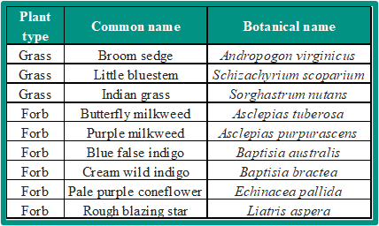Native grasses will be employed for roadside vegetation, in accordance with the USDOT “Pollinators and Roadsides: Best Management Practices for Managers and Decision Makers” and in consultation with Missouri Department of Conservation (MDC). Salt tolerant plants, especially, will be incorporated, as that will help them thrive along the roadway. Native plants in the area have already been identified by MDC and will be among those considered with this project, supporting water quality, pollinators, and other wildlife.

Table 2 Native Grasses



## Criterion #5: Equity, Multi-modal options & Quality ofLife

Equity

The OTO has developed an Equity Index application that identifies 13 categories of underserved populations at a more precise geography than census tracts. Nearly 20 percent of the residents within a half-mile of the corridor are below the poverty level compared to 6.7 percent for the encompassing census tract, as defined by the 2018-2022 Census ACS data. Within the same half-mile, almost 30 percent do not have access to internet at home, compared to 13.2 percent for the census tract. The inclusion of ADA sidewalk accommodations along the corridor is crucial to providing this population with access to employment spurred by the improved corridor. A ***primary project purpose*** is to support the economic development attracted to this area. These active and accessible improvements connect the disadvantaged communities with housing,

employment, and shopping. Public meetings have been hosted to gather equitable community feedback and inform the public of improvements to Hwy MM as well as proposed multi-modal options in the area.

**Engage Residents and Community-based Organizations to Ensure Equity Considerations for Underserved Communities are Meaningfully integrated throughout Project Lifecycle**

In a 2021 Community Survey, the City of Republic gathered resident feedback highlighting the demand for enhanced connectivity and alternative transportation, such as sidewalks and trails. Additionally, public comments received by OTO in 2021 underscored safety concerns due to increased traffic, contributing to the decision to propose improvements for the corridor.

Figure 7 Half-Mile Equity Hexbins

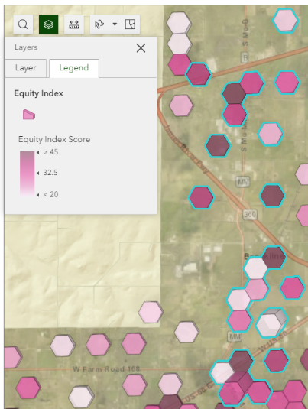

Using the OTO’s social equity index to analyze demographics, a public listening session was hosted by OTO and MoDOT at the Republic Community Center on February 28, 2022, attracting over 200 participants. Feedback, predominantly positive, focused on safety enhancements, job opportunities, and improved multimodal infrastructure. Concerns raised are being addressed in the project's design phase, with MoDOT considering mitigation strategies, including concerns for pedestrian safety. The OTO has documented public input on the corridor over the last decade, detailed in the grant application's public engagement section.

The OTO hired an Equity Engagement Consultant to facilitate equity engagement in Republic and its other member jurisdictions for a regional Safety Action Plan. The Equity Engagement Consultant conducted outreach in Republic as outlined in OTO’s 2023 Public Participation Plan, updated to include practices from Promising Practices for Meaningful Public Involvement in Transportation Decision Making. The outreach included a public meeting hosted at the Republic Community Center on January 30, 2024, Facebook ads and online surveys. Discussion included the Hwy MM project. This complements the targeted outreach for Hwy MM in 2022. MoDOT also hosted a public meeting on the Hwy MM project on April 2, 2024, directly adjacent to the proposed project.

Multi-Modal Options

The City of Republic advocates for providing sidewalks and trail systems allowing for healthy lifestyles and providing alternative modes of transportation. People can move to the project area and have mode choices, also providing opportunity to lower income individuals and families. Individuals can utilize bicycles to connect into the overall trail system. It will ensure access to healthy alternatives other than vehicles. The OTO prioritizes trail investments for the metropolitan planning area. There are planned trail connections from Hwy M (Republic Road near project) to the rest of the metropolitan planning trail system. The planned trail along Hwy MM will eventually connect into this trail system creating a travel network down to the Wilson’s

Creek National Battlefield (with 200,000 visitors annually) and into Springfield. The OTO Trail Dashboard is here: <https://www.ozarkstransportation.org/what-we-do/bikeped>.

Planned improvements to the corridor can greatly impact the traveling ability of current residents and future residents moving to the area. There are 714 residential units within two miles and **5,678** residential units planned. The sidewalk will improve ***access to daily destinations***, such as jobs (Amazon, McLane, Convoy of Hope, retail and restaurants), schools and library, shopping and restaurants (multiple along the corridor), health (nearby Cox Health facility), and recreation (new Republic Parks Sports Complex and Brookline Park).

Figure 8 OTO Proposed Trail Map

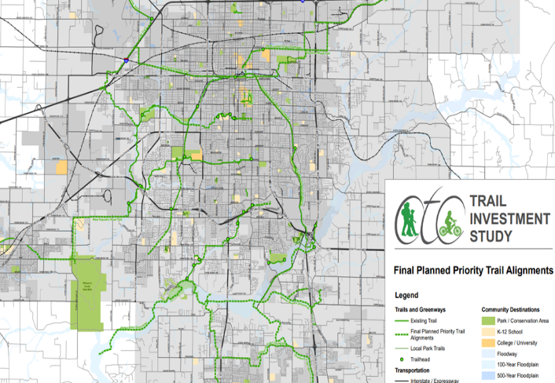

**Integrated Land Use, Affordable Housing, and Transportation Planning**

This infill growth between Republic and Springfield will allow residents to access services closer to home and provide for more compact travel patterns. The corridor has two planned mixed-use developments that include a combination of commercial retail and residential lots in the form of both apartments and single-family homes, providing opportunities for employees along the economic corridor to relocate closer to jobs. The City of Republic has seen **140%** housing growth and **3.9% population growth** in the **past 5 years** compared to the previous 5 years. There is a Springfield housing shortfall for the job growth in the Springfield metropolitan area. (Economic Leadership Report in Appendix)

Table 3 Projected Development, per approved permitting/development



A major developer has started a $65 million investment in the area, bringing a mixed-use housing development and retail area directly across from the Amazon Fulfillment Center. The investment in the area will provide apartments for individuals who would like to work at Amazon and other surrounding businesses and provide for them to do so without major transportation expenses or environmental impact. There are pedestrian crossing improvements included in this project at Haile St and Hwy MM to allow the 1,700 Amazon employees to safely cross the street to this and other retail across from Amazon.

The addition of sidewalk and pedestrian accommodations to the MO 360 bridge will provide for a walkable route to more job opportunities. Located further south along Hwy MM and next to the new road alignment will be another mixed-use housing and retail development. Stone Creek Falls, a 92-acre development, will have sidewalks and a trail connection to the new Hwy MM alignment. This is located near the newly announced intermediate school. The inclusion of active transportation along the corridor has encouraged these adjacent developers to include such amenities. The connectivity of private and public active transportation networks exponentially increases the benefits of either system on its own.

Figure 9 Iron Grain Mixed District Rendering and Amazon Facility

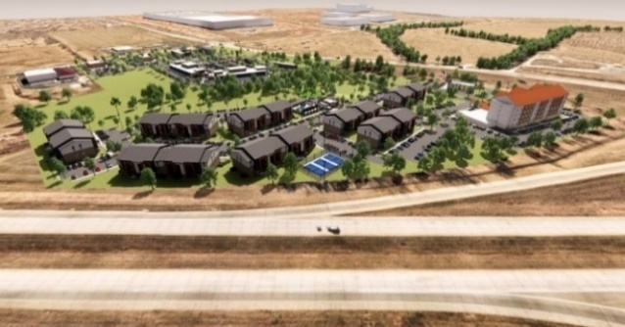

New Facilities that Promote Walking, Biking, and Other Forms of Active Transportation

The City of Republic purchased land in 2021 to build a 136-acre Park/Sports Complex with up to 10 baseball-softball fields, 8 soccer fields, 12 pickleball courts, a nature center, outdoor classrooms, playgrounds, and outdoor walking trails with an estimated construction cost of $40 million. The future park is located close to MO 360. This will contribute to the rapid increase in AADT to the corridor. The addition of sidewalks along the corridor will allow pedestrians to walk to the shared use path in the new alignment Phase I that is planned to eventually connect to the new City Park to create a walkable community.

The sidewalks would provide connections to Brookline Park, another existing City operated park, located off Hwy MM. Republic regularly hosts major regional and community events at the Brookline Park such as the “Got Mud? Run”. This is an annual event that draws in participants from twenty-seven cities and three states.

Figure 10 “Got Mud” Run Participants

The Republic School District purchased a 78-acre tract adjacent to the new road alignment of Hwy MM and across from the planned Stone Creek Housing Development. Project sidewalks will allow children to safely walk to the 800-student intermediate school and library.

The **Health Benefit** seen from the increased mobility is **$4,000,982 and $290,180 in Amenity Benefits** based on a projection of 130 sidewalk walkers a day. The numbers of walkers and bicyclists that would utilize the trails and sidewalks for the whole corridor to go to the new sports complex, school, and mixed used housing developments are likely to be much higher.

This project provides an opportunity to bring in a planned multi-modal system of travel to Republic, which will benefit the area for many years to come as it transitions to an urban area.

This project removes a roadway barrier for connectivity by completely moving the road and creating a safer connected corridor.

**Implement Plans, Based on Community Participation and Data, that Addresses Gaps Identified in the Existing Network**

Trail planning have been considered through *ConnectSGF* and the Ozarks Transportation’s *Towards a Regional Trail Plan* <https://tinyurl.com/MM2024MPDG>**.**

*ConnectSGF* considers the regional transit system and includes a proposed Hwy MM route. *Towards a Regional Trail Plan* outlines a regional connected trail system and calls for improved pedestrian connections*.* The project is also included in the Metropolitan Transportation Plan *Destination 2045* Constrained Project List as a principle arterial. The community voiced the need for sidewalks at the Hwy MM public meeting in 2022.

**Increasing Accessible Transportation Choices**

During the development of this area, the need for ADA accommodation was considered. There will be an ADA compliant 5-foot sidewalk that runs along one side of the corridor. This sidewalk will feed into the rest of the corridor and down to the 10-foot concrete shared use path that will allow for access to the trail system, parks, and allow for recreation and transportation.

**Removing Barriers to Opportunity**

The corridor contains and continues to add high quality job centers. Rural areas located in Southwest Missouri, Northwest Arkansas, Northeast Oklahoma, and Southeast Kansas will enjoy enhanced access to jobs as well as the products distributed from and through the businesses located along the project corridor. Access to Cox Health’s new “super clinic” on US 60, near the new alignment, provides for medical care and job opportunities in Republic and the surrounding areas. Over 3,300 jobs have been added along the corridor and 2,000+ more are projected with development.

Removing the congestion on the two- and three-lane segments and providing a safe corridor will enhance the quality of life for commuters. This quality enhancement found in the Travel Time Benefits from the BCA will enhance commuters going to jobs along the corridor, trucks hauling regional goods from I-44 or US 60, and commuters that live in the outlying communities that work and shop in Republic. Overall vehicular travelers along the corridor will see significant **Travel Time Savings** of **$9,484,569**, reducing transportation costs for supply chain companies and commuters.

**Collaborate with Public and/or Private Entities**

There have been private investments and partnerships leading up to the current project. Amazon invested approximately $4 million with the three-lane segment and signals in front of its facility. Amazon is actively working to train and retain workers from underserved areas in Springfield, MO through internal groups like the Black Employee Network affinity group. Amazon has

partnered with Missouri Job Center Ozark Region to conduct hiring events and assist underserved job seekers.

## Criterion #6: innovation – Tech, Project Delivery, & Finance

**Innovative Technologies**

* **Crowdsourced Data for Traffic Operations** – MoDOT is utilizing crowdsourcing to inform operations using third-party data gathered from apps such as Waze™ to alert travelers about delays, active field crews, assist with traffic incident management, and to identify issues such as potholes to help set road maintenance priorities.
* **LED Streetlights** – The use of LED Streetlights will significantly reduce the long-term maintenance costs due to high efficiency and long-life expectancy when compared to high pressure sodium or mercury vapor streetlights. Additional benefits include a reduction in carbon emissions and the ability to direct light on specific areas, supporting the Dark Sky Initiative. They can be dimmed allowing for more flexibility in controlling light levels.
* **Direct Current Charging Station** – An EV charging station will be located within two miles of I-44. This is along the I-44 alternative fuel corridor (pending status). Currently there are 83 miles between the two established stations. The goal is to expand access to charging or fueling within rural areas. It also gives vehicles a charging option for tourism connections down to the Wilson Creek National Battlefield. The exact location is still to be determined, but not in MoDOT right-of-way. The City of Republic will maintain the EV charging station. The station will be alternative fuel corridor compliant with at least four EVSE ports with CCS connectors and each supporting a power output of at least 150 kW.

**Innovative Project Delivery**

**Innovative Project Delivery components include:**

* **Post Award Value Engineering** – A post-award value engineering (PAVE) workshop will be conducted during the construction phase of the project. The PAVE workshop will increase the number of approved value engineering change proposals (VECP) and practical design value engineering change proposals (PDVECP), improve contractor partnering, streamline VECP/PDVECP approval process, and improve core team constructability knowledge.
* **Best Value Procurement** – MoDOT will follow a Best Value Procurement Process. Seeking quality and expertise will ensure successful and timely completion of the project.
* **Staged Construction** – The new roadway will be constructed in a manner that will provide only minimal periods of disruption to motorists utilizing the existing roadway network. To the extent possible, the portion of the new roadway located outside of the existing roadway will be constructed first while traffic continues to utilize the existing roadway. The existing roadway will be used and widened to both sides from I-44 to MO 360.

**Innovative Financing Components**

* **Revenue resulting from recent increase to the fuel tax** – The Missouri Legislature approved Senate Bill 262, a Fuel Tax increase. The $500 million in additional state revenue will result in a dedicated transportation revenue increase for the State Highway Fund.
* **Revenue resulting from a dedicated Transportation Sales Tax** – The City of Republic will be utilizing a dedicated 1/2-cent sales tax for transportation for the local share.