**HIghway mm: *corridor of opportunity***

# Project Budget

** Grant Funds, Sources, and Uses of all Project Funding

The Highway MM: *Corridor of Opportunity* consists of two phases from US 60 to I-44. Phase I (US 60 to Haile Street) is a realignment of Hwy MM that closes 3 at-grade railroad crossings, provides a BNSF overpass, provides a pedestrian underpass, installs a roundabout, and provides ADA sidewalks and a 10ft multi-modal side path. Phase II is the segment of Hwy MM, Haile Street to I-44. The total cost to complete the connected corridor comprised of Phase I & II is $67,904,827. The whole project consisting of Phase I & Phase II has been submitted for RAISE grants in 2022, 2023, and recently 2024. Due to the need to proceed with the realignment and railroad closures and the grant funding timeline of the MPDG announcements, the Phase I project segment was removed from the grant application. This MPDG-Rural application is for Phase II of the Hwy MM: *Corridor of Opportunity* project. The **$25 million in MPDG funds** would provide for a continuous section of highway and contribute to a project with **a total cost of $67,904,827**.

Table 1 Project Phase II Budget Table Table



The total estimated cost of the MPDG project application is **$29,585,992**. MPDG funding is critical to successfully deliver the Highway MM Corridor project. There is currently no identified funding for Phase II Component 1 (*I-44 to MO 360*) and Phase II Component 2 (*MO 360 to Haile Street*). This will result in a bottleneck of freight traffic once Phase I is complete. In the case an MPDG grant award of less than $25 million was awarded, the project scope would need to be reduced or changed in order to complete the project. The non-federal match contributions represent the maximum non-federal match that Missouri Department of

Transportation (MoDOT), City of Republic and Greene County can contribute. There is local match and private investment on the state system demonstrating the need for this project.



Table 2 Detailed Project Phase II Budget

Budget Funding

The USDOT MPDG Grant funding will contribute an estimated **$25,000,000** or **84%** of the overall project cost. The Non-Federal Funding Match Table (Table 4) shows the expected contributions toward the project.

**Census Tracts and Funding**

|  |  |
| --- | --- |
| Census Tract(s) | Project Costs per Census Tract |
| 48.05 | $ 29,585,992 |
| Total Project Cost  Table 3a Budget Table by Location Funding | $ 29,585,992 |

|  |  |
| --- | --- |
| Census Tract(s) | Project Costs per Census Tract |
| None | $0 |
| Total Project Cost  Table 3b Disadvantaged Census Track Funding | $ 0 Million |

|  |  |
| --- | --- |
| Urban/Rural | Project Costs |
| Urban *(2020 Census designated urban area with a population greater than 200,000)* | $0 |
| Rural *(Located outside of a 2020 Census-designated urban area with a population greater than 200,000)* | $29,585,992 |
| Total Project Cost | $29,585,992 |

Table 3c Designated Census Urban/Rural Funding

All funds in the project will be spent in a rural area.

Cost Share or Non-Federal Funding Match

Evidence of these pledged contributions are provided in the funding commitment documentation. All non-federal funds are immediately available and are not subject to a fixed time period.

Table 4 Non-Federal Funds Project Funding

|  |  |
| --- | --- |
| Project Non-Federal Funds Table |  |
| Greene County | $ 1.500 Million |
| City of Republic | $ 1.393 Million |
| State of Missouri | $ .405 Million |
| Total Non-Federal Funds | $ 3.298 Million |

MoDOT’s funding portion is $405,121 of state funds, generated from a non-federal funding source. The state funds are derived from Missouri user fees and include fuel taxes, registration and licensing fees, and motor vehicle sales taxes. The City of Republic’s portion of the project funding is $1,393,000 generated from a non-federal funding source from the city’s transportation tax revenue (Innovative Financing). Greene County’s $1,500,000 contribution is from local revenue (Road and Bridge funds).

Table 5 Federal Funds

Other Federal Funds

|  |  |
| --- | --- |
| Project Federal Funds Table |  |
| Surface Transportation Block Grant (STBG) | $ 1.240 Million |
| MPDG | $25.000 Million |
| Total Federal Funds | $26.240 Million |

Approximately $1,240,071 of the funds will be Federal Surface Transportation Block Grant funds.

Dependency of Other Funding Sources

Part of the project is programmed in the FY 2025 Missouri Statewide Transportation Improvement Program (STIP) to utilize Advanced Construction (Surface Transportation Block Grant) funds. These funds are part of Missouri’s allocated funding and has been prioritized for the project in the STIP as available funding sources for the project.

There has been no funding committed to the expanded project as proposed in this MPDG application, except for funds to match an MPDG grant award. Once the MPDG grant is successfully awarded the USDOT, MoDOT, Ozarks Transportation Organization (OTO), and the City of Republic will work together to ensure the grant timelines are met. The Missouri STIP and OTO Transportation Improvement Program (TIP) sheets are included in the funding commitment documentation. Upon award, MoDOT and OTO will put though the appropriate TIP and STIP amendments to add in the MPDG grant.

**Cost Estimates**

The cost estimates were updated January 2024. The cost estimates were prepared by MoDOT staff as part of preparation for the Highway MM project and updated for a FY 2024 RAISE Grant application. The cost estimates contain a 2% inflation factor. The cost estimates are included in the Supporting Documents Index.

**Degree of Design Completion for Cost Estimation**

The scope of work and detailed budget was developed from project cost estimates on design completion in various stages as outlined below:

* Highway MM Component 1 (I-44 to MO 360) – 35% design completion
* Highway MM Component 2 (MO 360 to Haile Street) – 35% design completion

**Contingency Amount**

A contingency amount of 4% has been added to the project cost estimate breakdowns contained in the project budget narrative to address additional inflation and finalized design on the Component 1 and Component 2 segments.

Any additional overrun costs would be provided by MoDOT, City of Republic, and other federal sources (Springfield area federal suballocated funds such as STBG, STBG-Suballocated, or CRP) to be outlined upon project award. These are estimates only and cover work that will be required regardless of other designs that MoDOT, the City of Republic, and USDOT implement. City of Republic will provide funds for the maintenance of the EV charger.

**Prior Project Costs**

The project has prior costs of $2,108,000 for engineering in FY 2022 and FY 2023. These costs have not been included in the grant budget or grant scope of work.

**Project Costs Incurred After Award and Before Obligation**

Work on the project and the incurred expense after award and before obligation will consist of the already programmed sections of the project as outlined in the Missouri Statewide Transportation Improvement Program. No work will begin on the project until the MPDG award announcements. Should the Highway MM project be awarded an MPDG grant, the project would not begin construction until obligation. The project schedule clearly outlines that the bulk of the overall project will happen in CY 2026 through CY 2028.

**Breakdown of Highway MM Cost Estimates**

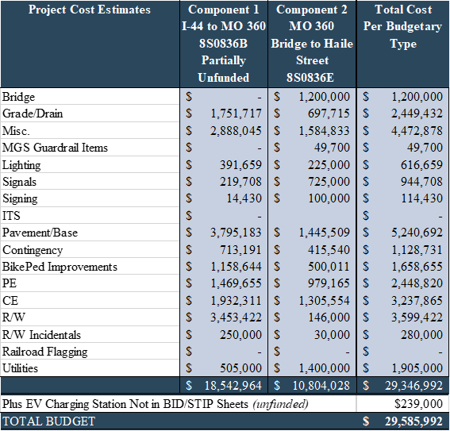

Table 6 Highway MM Cost Estimates

Per Section