HIGHWAY MM: CORRIDOR OF OPPORTUNITY

Project description
Project Description at a Glance
- Widening of Highway MM to 4-lanes from 2-lanes
- Widening of bridge over MO 360 to accommodate 4-lanes and pedestrian facilities
- Add ADA sidewalks along corridor
- Pedestrian crosswalk and signal at Haile Street
- Provide Direct Current Charging Station near I-44
The Highway MM: Corridor of Opportunity project aims to enhance safety, provide alternative modes of transportation, reduce congestion, and add capacity to a rural route that is rapidly becoming a regional economic hub. Missouri Highway MM connects Interstate 44 with MO 360 and US 60. Highway MM is a developing corridor and will continue to develop because there is interstate, rail, and air freight access nearby. It is a nexus of intermodal freight facilities with a pipeline located along the corridor. The corridor is growing with companies that provide above average wages with manufacturing, construction, and warehouse employers.
The proposed project will provide for safe community connectivity by turning a two-lane arterial into a divided four-lane with raised median facility. The improvement will deliver the ability to manage the truck and commuter traffic along the corridor.
Originally built in 1921, Hwy MM is a 3.95-mile north/south rural minor arterial with two 12-ft wide lanes with no existing sidewalks that connects to US 60 at its south end and to I-44 at its north end. The 2022 AADT was approximately 12,957 vehicles per day based on data provided on MoDOT’s Datazone website. The project location between I-44 and US 60, as well as the access it provides to existing and future traffic generators, make it subject to elevated levels of future freight congestion. Construction has accelerated along the corridor with new residential properties and commercial facilities such as Cox Health Center (medical center), Amazon STL3 Fulfillment Center (major warehouse employer), and Convoy of Hope World Headquarters (humanitarian aid distribution center). Additional commercial, retail, housing developments, and a 78-acre Republic School District campus with two new schools are currently being constructed along the corridor.
The City of Republic is one of the fastest growing regions in the state of Missouri and projects population growth from 19,832 in 2023 to approximately 33,000 people by the year 2040 (City of Republic). Highway MM serves as a primary route to the Springfield-Branson National Airport as well as the Wilson’s Creek National Battlefield. It is a major north/south connection for the region connecting Christian County and the west side of the City of Springfield to I-44. The Republic area serves several of the regional outlying communities as both a commercial and employment center. Because of its unique logistical advantages, the project corridor has experienced rapid and sustained economic development that continues to generate traffic, especially freight traffic, along the corridor.

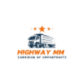
The project has four planned phases. Phase I is for Hwy MM from US 60 to Haile Street Intersection. Phase II consists of Hwy MM from Haile Street Intersection to I-44. Phase III is for Wilson Creek Boulevard extension from the US 60/Hwy MM Intersection through Hwy M. Phase IV is planned for I-44 and Hwy MM Interchange improvements. This MPDG application is only for Phase II of the Hwy MM Corridor project. A continuous four-lane corridor of opportunity and multimodal safe connectivity cannot be completed without MPDG funding.

Statement of work
MoDOT completed location and corridor studies in February 2022. The studies provide necessary information to identify needed improvements and ensure that those improvements are adequate in the future. MoDOT has started the NEPA process. Preliminary engineering began in FY 2022 and FY 2023. Those costs are not included in the project scope.
The proposed facility has a functional classification of rural minor arterial, but has a Major Thoroughfare Plan (MTP) classification of Primary Arterial. The project will be designed on the MTP classification of Primary Arterial with a design volume of 31,600. The design criteria that will be used for the corridor: Design AADT 31,600; Operational (Posted) Speed - 45 miles per hour; 4-lanes, 82-ft Roadbed Width; 130-ft Right-of-Way width, curb and gutter, storm water facilities, 5-ft wide ADA sidewalk facilities. Preliminary Engineering Bid Sheets are included in the Supporting Documents Index and at https://tinyurl.com/MM2024MPDG.
Phase II (MPDG Request)
I-44 to MO 360 (Grading, Drainage, and Paving) 1.66 miles
Project adds lane capacity (two-lanes to four-lanes with raised median). Project adds ADA sidewalk accommodation along the corridor. EV Charging Station construction and installation near Interstate 44 is included.
MO 360 to Haile Street (Grading, Drainage, Bridge, and Paving) .87 miles
Project adds lane capacity (three-lanes to four-lanes, currently three-lanes due to Amazon’s safety investment). Project adds ADA sidewalk accommodation along the corridor. There is currently a diamond interchange with MO 360. This bridge will be widened to accommodate four-lanes and pedestrian accommodations. Pedestrian signal and crossing will be added at the Haile Street Intersection.
Phase I (Currently Planned)
Haile Street to US 60 (Grading, Drainage, Bridge, Paving-New Construction) 1.08 miles
Part of the project will realign Hwy MM from the current US 60/Hwy MM Intersection, constructing a four-lane cross-section between US 60 and Farm Road 160 and a new signalized intersection at US 60 and Hwy MM. It also permanently closes and removes three at-grade railroad crossings. It closes through access to Hwy MM at current US 60 Intersection and Farm

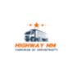
Road 103. Project adds new ADA sidewalk accommodation along the corridor. A new overpass over the BNSF railroad is included with bicycle and pedestrian access. A 10-foot shared use path is proposed along the new alignment for community connectivity and multimodal travel options. It includes a two-lane roundabout intersection at Farm Road 160 to accommodate the anticipated development growth and pedestrian safety.

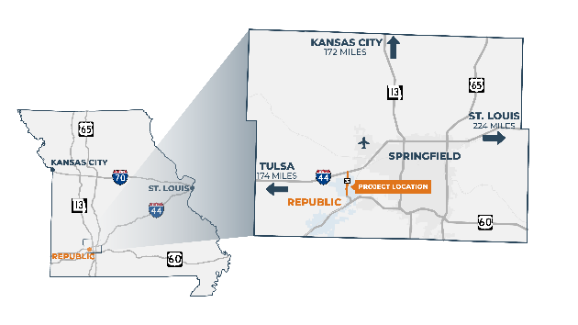
transportation challenges
Hwy MM connects two major corridors. Interstate 44 has been identified as a critical Tier I high priority freight corridor in the State of Missouri. See 2022 Missouri State Freight and Rail Plan here: https://tinyurl.com/MM2024MPDG. Hwy MM also connects to US 60, a 2,655-mile (in total) east/west route which runs the entire length of Missouri connecting Oklahoma to Kentucky. It is also a major east-west route connecting Southwestern Arizona to the Atlantic Ocean in Virginia. These key corridors transport vital products to the whole nation. Missouri is a national crossroads of highway, rail, and pipeline networks. With the logistic challenges faced by the nation during the COVID pandemic, a strong freight infrastructure has become even more important for transporting necessary supplies. Hwy MM is a primary route to the Springfield-Branson National Airport.
Figure 1 2022 Missouri Project Location & Freight Connections
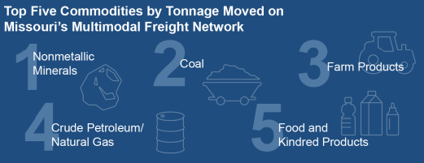
Hwy MM is already experiencing poor levels of service and when current and future development is modeled, the route will quickly be unable to manage the growing demand. Sections of the corridor are already performing at a level of service (LOS) D or F (Greene County Route MM/ZZ Study). Most of the corridor is a two-lane facility. There is one three-lane section on Hwy MM that is expected to exceed capacity after 2027.
Most of the corridor lacks adequate shoulders, turn lanes, and pedestrian connections. Frequent conflicts with large trucks and passenger vehicles cause serious crashes as shown by the documented crash history.
Figure 2 2022 MoDOT State Freight and Rail Plan

addressing the challenges
This project will address the following challenges that will be explained further in the Outcome Criteria Narrative:
- Adding capacity to the roadway to manage the freight transports and commuters.

- Adding ADA sidewalk to allow pedestrian access to the corridor that previously did not exist.
- Reducing truck-passenger car conflicts by adding center turn lanes and raised medians.
- The planned project addresses both existing and future concerns due to growing traffic volumes within the corridor. The project has been designed to accommodate freight and commuter traffic through 2048.

project history
In 2005, the City of Republic, Missouri made an innovative decision to consolidate the Village of Brookline into Republic, approximately 2,560 acres, to facilitate the development of the Brookline Business Park. The City of Republic has made historic infrastructure investments in water, sewer, and fire protection totaling over $169.5 million. The Springfield, MO utility, City Utilities, also believed in the vision to bring quality jobs to the region and invested in electric and natural gas infrastructure. What once was open land with great connections to essential road freight corridors, rail, and the airport has become a booming freight corridor with businesses moving in rapidly.
The City of Republic previously applied for a TIGER Discretionary Grant in 2009 and 2017 (Republic Regional Business Corridor) for this corridor in anticipation of this growth. The Ozarks Transportation applied in partnership with the City of Republic and MoDOT for a RAISE Discretionary Grant in 2022, 2023, and 2024. If the Ozarks Transportation Organization is successful with a 2024 RAISE award in the amount of $25 million, MPDG funding would not be needed.
The project became a high priority in 2020 when the Convoy of Hope World Headquarters and Amazon STL3 Fulfillment Center were built. In 2021, Amazon constructed over $4 million in transportation improvements to the Hwy MM corridor by upgrading a three-lane roadway from MO 360 to Farm Road 160. Two public roadway intersections were improved including Farm Road 156, which serves commercial development, and Haile Street, which serves residences. Finally, traffic signals were added to the northern interchange ramp of MO 360, Farm Road 156, and Haile Street. While Amazon made the improvements needed to facilitate the demands of traffic they caused, the remainder of the corridor is still experiencing congestion. Amazon has also contributed $436,266 towards intersection improvements that are part of the Phase I project.

Project Location
Figure 3 Project Coordinates
Rural/Urban | Latitude | Longitude | Length
Rural | 37° 10’ 53.57” N | 93° 25’ 25.52” W | 1.66 Miles
 | Hwy MM @ 1-44 | Northern Limit
Rural | 37° 09’ 52.588” N | 93° 25’ 27.147” W | 0.87 Miles
 | Hwy MM @ Haile Street | Southern Limit

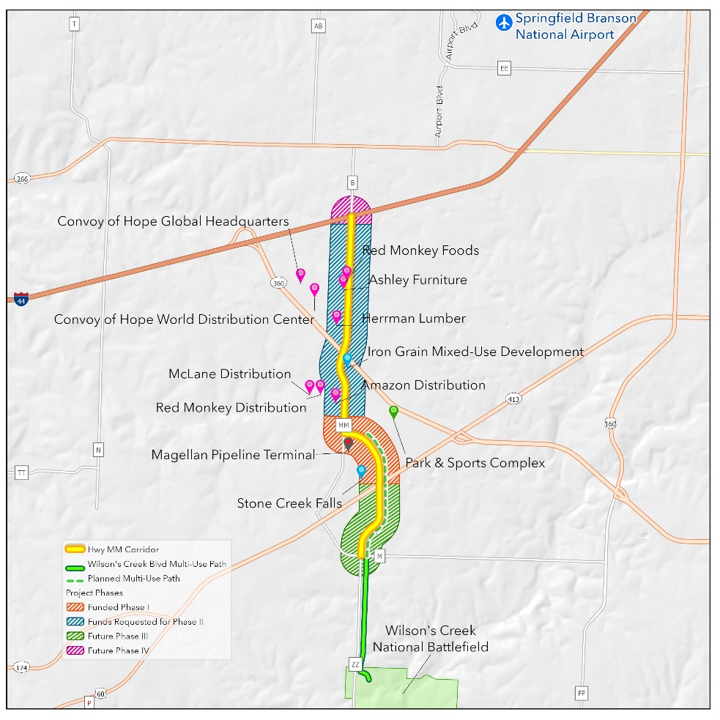
The proposed project is located on the rural segment (per the 2020 census) of Hwy MM between Interstate 44 and US 60. The project is located three miles from a major population center of Springfield, MO and connects the City of Willard commuters to the City of Republic community. The project is in the Missouri Department of Transportation (MoDOT) Southwest District, the Ozarks Transportation Organization (OTO) Metropolitan Planning Organization planning area, and in the city limits of the City of Republic.
Figure 4 Project Location Map
Area of Persistent Poverty & Historically Disadvantage Area
The project is in the 48.05 Census Tract of Greene County, Missouri. Greene County is not identified as an Area of Persistent Poverty. The project is not in a historically disadvantaged community. However, this project will increase access to jobs and education in the
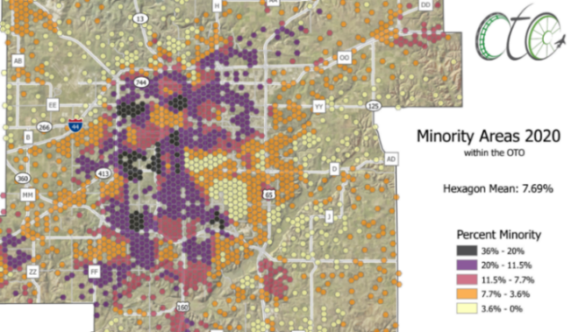
area. Jobs created in this corridor provide opportunities for the disadvantaged communities in Census Tracts 17, 31, 32, 33, 48.02, 58.01 and 58.02. The project is located outside the Springfield Missouri Urbanized area and is designated as rural in the 2020 Census.
Figure 5 OTO Minority Areas Map

