**HIGHWAY MM: *CORRIDOR OF OPPORTUNITY***

# Project schedule

Missouri Department of Transportation (MoDOT) conducted studies on the MM/I-44 Interchange and US 60 to analyze how the project will affect the system. Environmental work is underway, and a CE2 is anticipated. MoDOT has already begun the consultation process with other agencies and has identified only a few areas remaining to be addressed.



Assuming that the grant awards are announced by November 2024, construction will begin by February 2027 (PS&E Sept 2026, Letting November 2026). The project will be fully constructed by December 2028. The project will be obligated well in advance of the September 30, 2028, obligation deadline.

## Environmental Risk

MoDOT began the NEPA process with only a couple pending items. Environmental work is underway. MoDOT has already begun the consultation process with other agencies and has identified only a few areas to be addressed.

NEPA Approval

The NEPA clearance process for the Highway MM Project is ongoing. CE2 clearance is expected and FHWA concurrence has been obtained (email from FHWA is included in Supporting Documents Appendix). An approval checklist is included in the required approval section.

**Environmental Permits and Reviews**

Preliminary and/or Right-of-Way level Environmental Services (RES) were reviewed and returned on the project. A CE2 is pending to achieve NEPA clearance.

Table 1 Environmental Services Clearance Status Checklist

## Logo Description automatically generated with medium confidence Community Input

Public Engagement

The Ozarks Transportation Organization (OTO) and MoDOT have conducted public engagement with the community on how to improve Highway MM. Feedback has been incorporated into the design and priority process.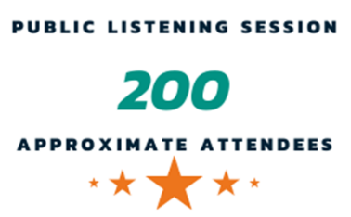 The OTO, throughout the Metropolitan Planning Organization (MPO) planning process, has a data-driven system of ranking the area’s priorities. This project has been scored as a high priority for the region.

OTO and MoDOT conducted a public listening session on February 28, 2022, to solicit feedback regarding the project at the Republic Community Center. There were approximately two hundred attendees at the public meeting. The feedback was primarily positive on the project. Concerns have been noted by MoDOT and attempts to mitigate concerns are being considered in the project design, including incorporating pedestrian sidewalks along the corridor. The OTO has maintained a public input log of issues along the corridor for the last ten years. The table below provides links to the project websites, which provide documentation on the outreach efforts to-date. MoDOT had a public meeting on the project in April 2024 with **69 attendees**.

|  |
| --- |
| Highway MM Public Engagement Links |
| OTO <https://www.ozarkstransportation.org/highway-mm-corridor-raise-grant> |
| MoDOT <https://www.modot.org/greene-county-route-mmzz-corridor> |

## required approvals

**State and Local Government Approval**

The City of Republic, Greene County, and MoDOT support this project. In addition, the Metropolitan Planning Organization Board of Directors also supports the project and has taken action to certify the inclusion of the project if awarded in the Transportation Improvement Program. Part of Component 1 is included in the Missouri Statewide Transportation Improvement Program (STIP) and Ozarks Transportation Organization’s Transportation Improvement Program (TIP). All components of the project are also included in the OTO’s Long Range Transportation Plan *Destination 2045*. The STIP and TIP pages are included in the funding certification document. The only approvals that would be needed are the TIP/STIP amendments to add component 1 and 2 of the project and the action to sign the agreements with Federal Highway Administration to begin the project.

**Studies**

MoDOT commissioned two studies along the corridor to arrive at a long-term solution for the transportation issues along the corridor.

*Greene County Route MM/ZZ Corridor Study* was commissioned to address existing and future concerns due to growing traffic volumes within the Route MM and Route ZZ corridors. Multiple alternatives were considered to address crash history and eliminate at-grade railroad crossings in the area.

*Route MM/ZZ Corridor Study (James River Freeway to Route M)* was commissioned to provide traffic analysis, modeling, and forecasting for staged project implementation of the conceptual Highway MM corridor realignment to meet projected forecasts.

**Federal Transportation Requirements Affecting State and Local Planning**

The Highway MM Corridor project is listed as a Priority Project of Regional Significance with the OTO (area’s MPO). Phase I (Highway MM realignment) and part of Component 1 of the project is also included in the Statewide Transportation Improvement Program (STIP) and the OTO’s current Transportation Improvement Program (TIP). Upon the award of the MPDG, the current TIP and STIP would need to be amended to add the portion financed by the MPDG funding. The OTO, MoDOT, and the region support the project, so it would be easy to accommodate the project additions. See Funding Certification Document for Transportation Improvement Program Inclusion Certification.

**Assessment of Risks and Mitigation Strategies**

Many risks, and the strategies to mitigate or avoid any crises, were evaluated as follows:

* **Right-of-way:** There are 11.5 acres in total with .5 acres of tree clearing are required. Right-of-way acquisition will be completed in accordance with 49 CFR part 24, 23 CFR part 710 by MoDOT and the City of Republic, who have extensive experience in all aspects of acquisition. There are 28 parcels impacted with an approximate cost of $3.6 million.
* **Floodplain:**  A floodplain development permit from SEMA will not be required.
* **Section 106:** An archaeological survey was completed, and a letter of concurrence received in September 2022. Architectural SHPO clearance is under internal MoDOT review and SHPO clearance for most of the project was received March 2023.
* **Weather** (rain, snow, severe weather delays): The project schedule will factor in severe weather days.
* **Higher costs than originally estimated:** Value Engineering is a part of the design process and will reduce budget risk. MoDOT has a proven history of estimating extremely accurately and typically delivers under budget. Inflation and a contingency budget have been factored into the project.

The process of right-of-way acquisition will be completed within the MPDG project schedule. The environmental assessment process is almost complete. There are no properties that qualify as land or hazardous waste sites. There are no wetlands that exist within the project boundaries. Property based on projected development will be primarily residential, commercial, and industrial activity.

## Logo Description automatically generated with medium confidence Technical capacity

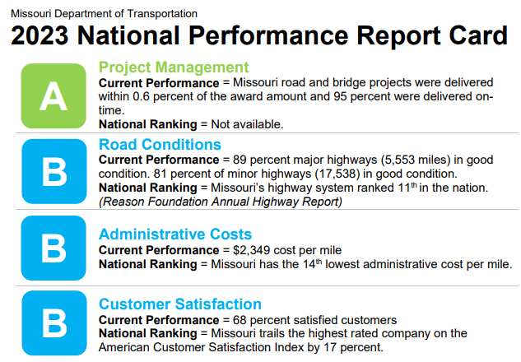The project upon award will be transferred to MoDOT for project administration. MoDOT has considerable experience in the development and implementation of large and complex transportation capital projects, including the completion of the I-49 Missouri/Arkansas Connector project funded through the BUILD program and the New Champ Clark Bridge funded through the TIGER program. In addition, MoDOT plans, designs, constructs, and maintains 33,859 miles of highways and 10,385 state highway bridges (24,385 bridges statewide) – the nation’s seventh largest state highway system, with more miles than Iowa, Nebraska, and Kansas’ systems combined. MoDOT stands ready to deliver the proposed MPDG project upon award. MoDOT continues to be recognized with awards as shown in the appendix.

# Benefit Cost Analysis

Overall, the project’s net present value is estimated to be **$38,699,421** over 20 years, when discounted, with a benefit-cost ratio of **2.54**. The largest benefits are due to travel time savings ($9.48 million), safety ($41.8 million), and emissions ($9.97 million) are expected. The full benefit-cost analysis is provided in the BCA Narrative.